**Lesson Notes**

1. What is the main purpose of an Operating System?
   1. The main purpose of an operating system is for a simpler and an increasingly more efficient use and application of a program, a consistent user experience, and combined with a multi – applications run, makes the operating system viable to the computer.
2. What is the difference between Operating System Software and Use Application Software?
   1. The difference lies in the purpose of both the ideas. The operating system takes care of the input systems regarding the keyboard, and mouse inputs. Unlike the operating system, the application software doesn’t care about the other systems and only focuses on the specific application currently running, it only wants input, but doesn’t know how to do it.
3. What is the difference between Operating System Software and Computer Hardware?
   1. The operating system is the program that intakes the input data and uses it to control the hardware in the computer. The hardware is also independent and can be run on different computer hardware because of similar configurations, their user interface, and resource allocation.
4. What are the main parts of an Operating System?
   1. The main components include the graphical user interface (GUI), the system calls, device drivers, the Input/output manager, memory manager, process manager, and the security monitor.
5. What are some popular operating systems?
   1. Some popular operating systems are Windows OS, Mac OS, Linux / Unix, Android, and iOS.

# Notes

1. Simpler / More Efficient Application Programs
   1. Operating System handles the Computer Hardware
   2. Operating System handles resource allocation
2. Consistent User Experience
   1. Operating System provides a standard User Interface (Windows)
   2. Operating System provides a standard way to store and browse data files and folders (File Explorer)
3. Allow Multiple Applications Running At Same Time
   1. Operating System Provides Ownership Control (User Accounts)
   2. Operating System Schedules, the CPU (Task Sharing)
4. Hardware Independence
   1. Same applications can run on different computer hardware
   2. Operating System must be configured according to hardware components present in the computer
5. User Interface
   1. Applications focus on what is contained and displayed within a window
   2. Operating System controls opening / closing / resizing windows and responding to mouse and keyboard actions
   3. Operating System provides standard ways to print, save and open files, access the internet, etc.
6. Resource Allocation
   1. Applications just ask for what they need (e.g. Memory, Disk Space)
   2. Operating System checks for availability and access permission
   3. Operating System coordinates resource allocation between applications

**Reference Diagram**

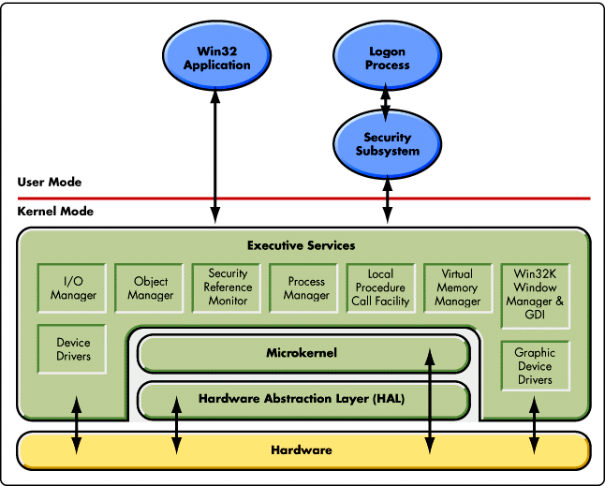

**Student Questions**

1. What is a device driver?
   1. Provide a brief summary
      1. The device driver is a device that allows the computer to know of the specifications of a certain piece of hardware. If there is no device driver, the computer will not be able to communicate with the hardware.
   2. List some devices that require a device driver.
      1. Hard Drives
      2. DVD Drives
      3. PCI Cards
   3. Provide a label on the reference diagram for the location of a device driver for your graphics card.
      1. It is on the bottom right of the reference diagram.
   4. Provide a label on the reference diagram for the location of a device driver for a locally attached printer.
      1. It is on the bottom left of the reference diagram.
2. What is a DLL?
   1. Provide a brief summary
      1. DLL (Dynamic – Link Library) is a file in Microsoft’s library for a sharing concepts in file based systems.
   2. Explain how DLLs are related to user application programs
      1. DLLs are files that contain assembly language that is not directly executable.
   3. Provide a label on the reference diagram for the location of a DLL
      1. It is in the project manager.
3. What is a windows manager?
   1. Provide a brief summary
      1. The windows manager is the program that manages all the windows currently open in the screen.
   2. Explain how a windows manager is related to user application programs
      1. Its relation is when a user wants to move their windows around, specifically the applications, this allows multiple applications to be opened and seen at once.
   3. Provide a label on the reference diagram for the location of a DLL
      1. It is probably in the Win32K Window manager and GUI.
4. What is the windows task manager?
   1. Provide a brief summary
      1. The task manager allows the user to view and access processes on the current running applications.
   2. List and explain four (4) types of system information provided by the task manager
      1. It gives you details of programs running on the computer, their performances on the processes, details of the current running applications, and on those applications that have stopped running.

* 1. Provide a label on the reference diagram for the operating system components related to each type of information.
     1. They are referenced in the Process manger, local procedure call facility, and the vital memory manager.